**Introduction**

Internet of Things (IoT) was ﬁrst introduced to the community in 1999 and with the aim of “making a computer sense information without the aid of human intervention” was widely adapted to other ﬁelds such as healthcare, home, environment, and transports. Now with IoT, we will arrive in the post-cloud era, where there will be a large quality of data generated by things that are immersed in our daily life, and a lot of applications will also be deployed at the edge to consume these data. Some IoT applications might require very short response time, some might involve private data, and some might produce a large quantity of data which could be a heavy load for networks. Cloud computing is not efﬁcient enough to support these applications. With the push from cloud services and pull from IoT, we envision that the edge of the network is changing from data consumer to data producer as well as data consumer. In this, we attempt to contribute the concept of edge computing. We start from the analysis of why we need edge computing, then we give our deﬁnition and vision of edge computing.

**What exactly is Edge Computing according to research firms?**

* Gartner’s definition of edge computing: “Gartner defines edge computing as solutions that facilitate data processing at or near the source of data generation. For example, in the context of the Internet of Things (IoT), the sources of data generation are usually things with sensors or embedded devices. Edge computing serves as the decentralized extension of the campus networks, cellular networks, data center networks or the cloud”.
* A network of micro data centers that store or process critical data locally and push received data to a centralized data center or repository of cloud storage.
* Typically in IoT use cases, a massive chunk of data goes through the data center, but edge computing processes the data locally results in reduced traffic in the central repository.
* This is done by IoT devices, transferring the data to the local device, which includes storage, compute, and network connectivity.
* After that, data is processed at the edge while another portion is sent to storage repository or central processing in the data center.

**Edge Computing and Working**

Edge computing is a mesh network of micro data centers that process or store critical data locally and push all received data to a central data center or cloud storage repository.

Edge computing is a method of optimizing cloud computing systems by performing data processing at the edge of the network, near the source of the data. This reduces the communications bandwidth needed between sensors and the central datacenter by performing analytics and knowledge generation at or near the source of the data. This approach requires leveraging resources that may not be continuously connected to a network such as laptops, smartphones, tablets and sensors.

Edge computing covers a wide range of technologies including wireless sensor networks, mobile data acquisition, mobile signature analysis, mobile edge computing, distributed data storage and retrieval, autonomic self-healing networks, remote cloud services, augmented reality, and more.

At first the data is collected by the devices and then the data is processed at the edge, and all or a portion of it is sent to the central processing or storage repository in a corporate data center.

‘Edge’ refers to the computing infrastructure that exists close to the sources of data, for example, industrial machines (e.g wind turbine, magnetic resonance (MR) scanner). These devices typically reside away from the centralize computing available in the cloud.

The role of edge computing has mostly been used to ingest, store, filter, and send data to cloud systems. We are at a point in time, however, where these computing systems are packing more compute, storage, and analytic power to consume and act on the data at the machine location. This capability will be more than valuable to industrial organizations.

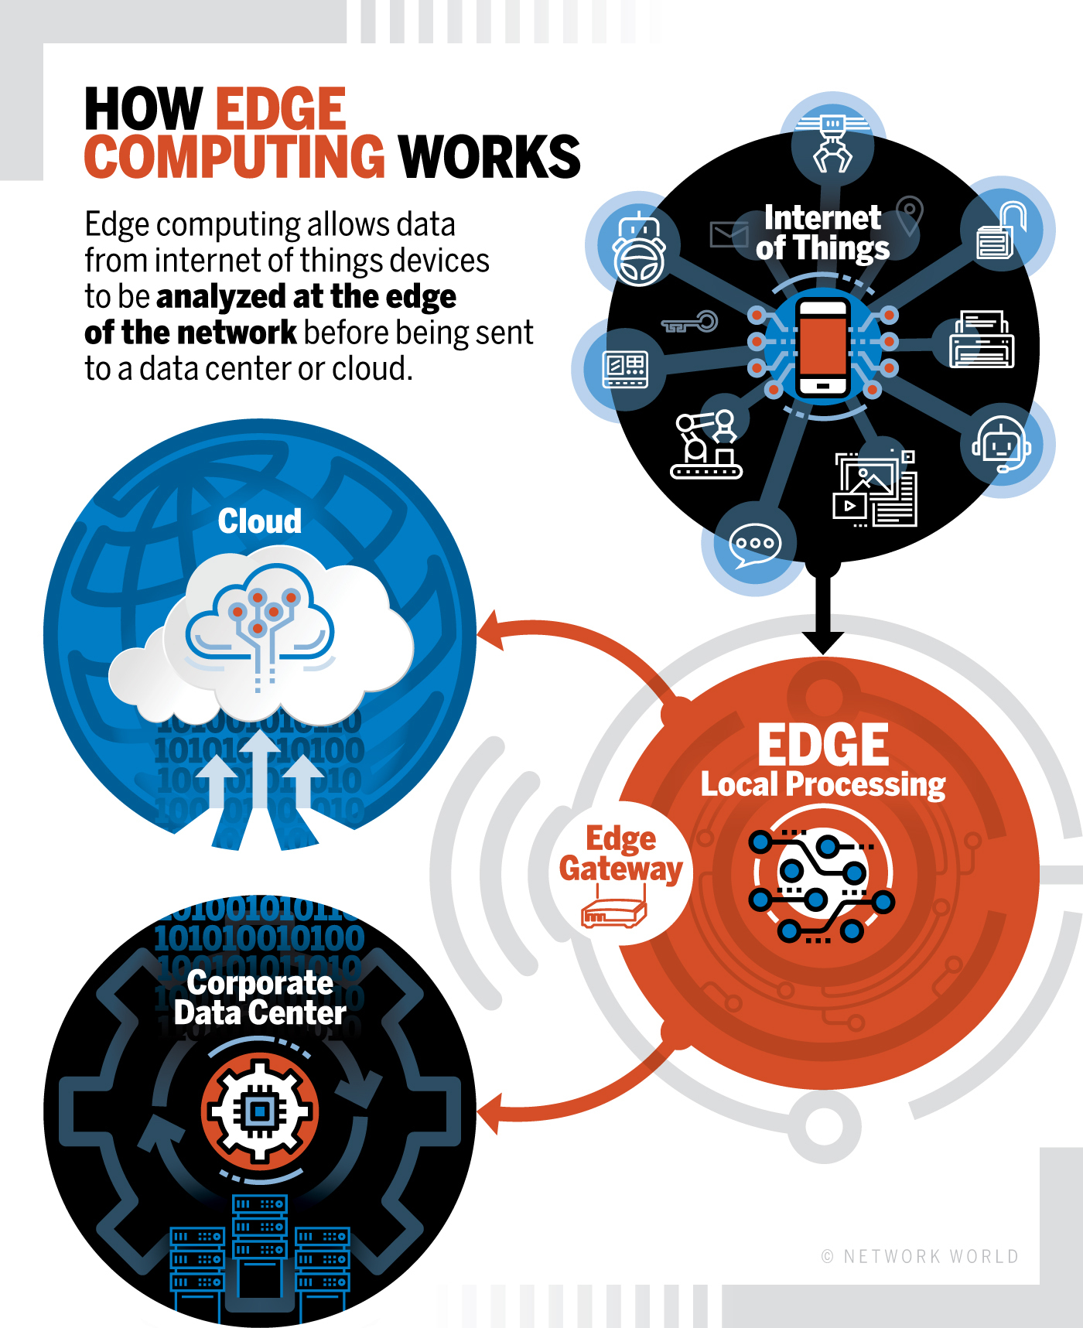

**Edge computing terms and definitions**

**Edge:** In a telecommunications field, perhaps the edge is a cell phone or maybe it’s a cell tower. In an automotive scenario, the edge of the network could be a car. In manufacturing, it could be a machine on a shop floor; in enterprise IT, the edge could be a laptop.

**Edge server:** Edge servers can be defined as a computer for running middleware or applications that sits close to the edge of the network, where the digital world meets the real world. Edge servers are put to distribution centers and factories.

**Edge devices**: These can be any device that produces data. These could be sensors, industrial machines or other devices that produce or collect data.

**Edge gateway**: A gateway is the buffer between where edge computing processing is done and the broader fog network. The gateway is the window into the larger environment beyond the edge of the network.

**Fat client**: Software that can do some data processing in edge devices. This is opposed to a thin client, which would merely transfer.

So, for a mix of reasons (bandwidth, costs, speed, maintenance, predictive analytics) we need a faster, cheaper and smarter approach than the traditional one which typically goes like: gather the data, send them through networks to the cloud or other environments where they can get processed and leveraged and so forth.

That’s where both edge computing really come in. If your data is generated at the edge in IoT, then why not bring all your intelligence and analysis as close to the edge, the source, as possible, with all the obvious benefits. And it’s also where those promised forecasts on edge computing and IoT come in.

**Edge computing vs. cloud computing**

First of all, we need to say that **edge computing** is a special computing infrastructure existing at the edges of data sources, e.g devices (industrial machines like turbines, magnetic resonance systems, self-driving cars, smart homes, and other smart devices envisaging incorporating many sensors and operating with their data). In other words, it’s pushing the computing applications frontier away from centralized nodes to the network extremes. That means edge computing requires leveraging device resources so that they don’t need to be connected to the network (or data center) continuously.

The opposing method, **cloud computing**, requires that all things be connected to the central data storage, where huge volumes of information are processed to find optimization solutions or make business decisions. As a rule, cloud computing is associated with complex data processing operations requiring significant computational power. At the same time, data accumulation and processing are not quick enough to be applied in some special spheres where the computational results need to be applied instantly.

The problem with cloud computing is widely known. It’s resulted in the appearance of a middle tier in the data circulation model – fog computing. Fog computing is an attempt to push computing powers closer to the data sources, eliminating response times without affecting efficiency. In fog computing, the computing is distributed in the most logical, efficient place between the data source and the cloud – in a “fog”. Fog is territorially closer to the devices as compared to the cloud, however, it’s still just a middle chain pushing the information further even if it’s able to make some decisions on the fly.

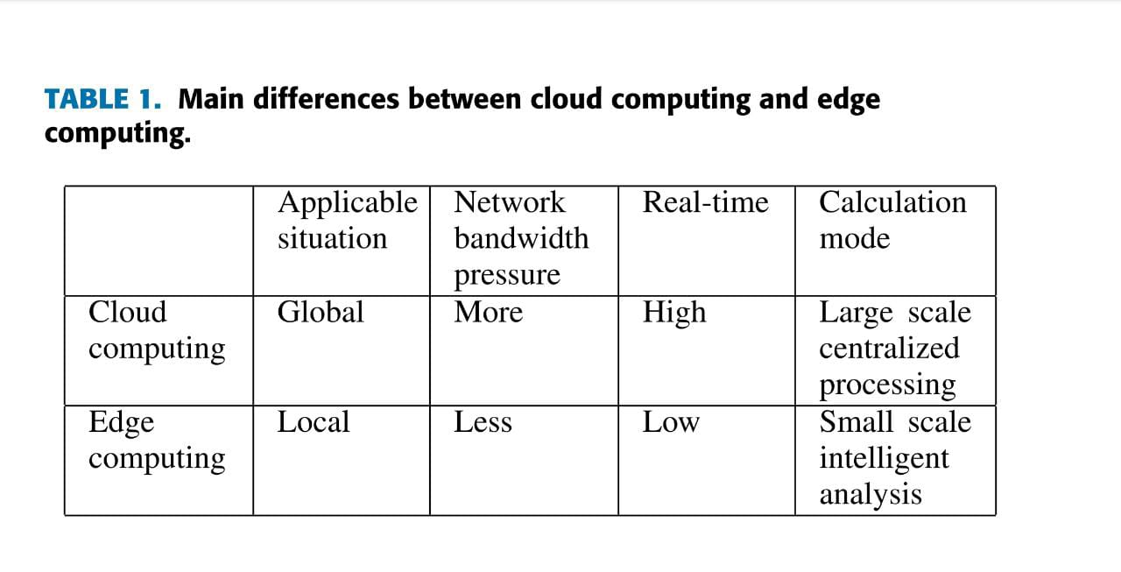

**Benefits of Enabling Edge Computing for the Internet of Things (IoT)**

* Lesser Network Load
* Zero Latency
* Reduced Data Exposure
* Computational Efficient
* Costs and Autonomous Operation
* Security and Privacy

**Why is Edge Computing Important?**

* New Functionalities are offered.
* Easier configurations.
* Hacking Potential is increased.
* The load on the server is reduced.
* Load on Network is reduced.
* Application Programming Interface.
* Increases Extensibility.
* Centralized Management.

**APPLICATIONS**

**Use of Edge Computing related to Industries**

* Smart applications and devices respond to data, instantly eliminating lag time.
* Real-time data process with any latency where even milliseconds in latency make a difference in the processing of data.
* Efficient data processing in massive data.
* Effective use of the application in a remote location.
* Security for sensitive data even without putting in the public cloud.

**Role of Edge Computing in Healthcare**

* For example, in the hospital, we collect data from IoT devices, which is monitoring patients and transfer it to the trust’s electronic health record (EHR) from the bedside, with the authentication of staff to the IoT devices through proximity cards.

**Role of Edge Computing in Social Good**

* Environmental factors like road traffic density, air quality, weather, school holidays, and other open data sets give better results by the processing of data with the help of edge computing and machine learning.

**Future Directions of Computing**

* Use of 5G.
* Use of AI and ML.
* A growing list of vendors will provide edge computing products and services.
* Future edge based applications.

**CONCLUSION**

* As we are moving to a world with lots and lots of data and data processing, the need of a faster connection is becoming crucial.
* While a centralized data center or cloud for data management, processing, storage has its limitations edge computing can provide an alternative solution for this.
* With edge computing things have become more efficient. As a result the quality of business operations has become higher.

**BIBLIOGRAPHY**

1. [www.ibm.com](http://www.ibm.com)
2. [www.intel.com](http://www.intel.com)
3. www.Jelvix.com
4. [https://ieeexplore.iee.org](https://ieeexplore.iee.org/)
5. [www.linkedin.com](http://www.linkedin.com)